

Travlr Getaways

CS 465 Project Software Design Document
Version 1.2

Table of Contents

CS 465 Project Software Design Document 1
Table of Contents 2
Document Revision History 2
Executive Summary 3
Design Constraints 3
System Architecture View 4
Component Diagram 4
Sequence Diagram 5
Class Diagram 6
API Endpoints 7
The User Interface 8

Document Revision History

Version | Date | Author | Comments
1.0 | 09/13/2025 | Daniel Gorelkin | Initial proposal – First revision
1.1 | 09/20/2025 | Daniel Gorelkin | Diagrams and endpoints proposal
1.2 | 10/06/2025 | Daniel Gorelkin | Outlining the user interface

Executive Summary

Based on the given requirements to create a responsive website that will provide customers with the ability to log in with username and password, search travel packages, and place orders, as well as a dedicated password-protected admin page from which the admin user can update and manage travel packages, we chose to build the website following the MEAN architecture which will provide faster development, great flexibility and scalability, as well as performance and security. Your website will be built using the Express framework, which will allow you to run a database server on premises or remotely, while the script itself will be executed in JavaScript directly on the user’s mobile device or desktop. This approach will reduce computation on the server side (backend) and provide fast and efficient page loading, while delivering a great user experience at the front end (the application interface).
As mentioned, the website will be built upon the MEAN architecture that will consist of the MongoDB database to store the data, the Angular front end framework that will support fast data rendering and templating, and finally, the application server layer that will act as a glue to communicate between the front and the back ends by using Node.js (a server library), and Express (to execute all of the above and run the server). As a result, the MEAN stack will have a Representational State Transfer (REST) API that feeds data to the static HTML pages (and vice versa) of the application using JSON-type content.
With this in mind, the hybrid architecture will support a single REST API feeding two separate user-facing applications, built using different parts of the MEAN stack to provide the most appropriate solution for both the customer-facing side of the application and the administrator single-page application (SPA). Hence, the customer-facing side will behave like a traditional, neatly designed multi-page HTML website, while the administrator's single-page application will pull only the required data from the database and render only the necessary parts of the page, managing the entire website content from a single page. This provides a fast and smooth user experience.

Design Constraints

Obviously, there is no single solution that fits all. Running the MEAN architecture might have some constraints and boundaries. One of the main disadvantages of using MEAN Stack is that it might perform poorly on mobile devices (compared to a large screen device) due to the absence of native mobile applications for AngularJS. Additionally, the MEAN Stack is built upon MongoDB, a NoSQL database; hence, it does not support ACID transactions, which would require adding complexity to the actual credit card payment option. The main challenge lies in promoting the website organically through SEO. Because content is rendered client-side through templates, search engines might struggle to read and index the content. A solution for it could be in the form of prerendering or using Angular Universal, which will add extra development time and complexity.
Finally, security considerations such as preventing SQL/NoSQL injection, XSS, and CSRF attacks, including masking sensitive data like customer profiles and payment information, will require secure sessions through an HTTPS connection and SSL certification. Despite the boundaries described above, choosing the architecture mentioned will result in a highly extensible and maintainable website, with outstanding performance and security in mind, which ultimately leads to high customer attraction, a high volume of traffic, and a high conversion rate, e.g., closed deals.

System Architecture View

Component Diagram

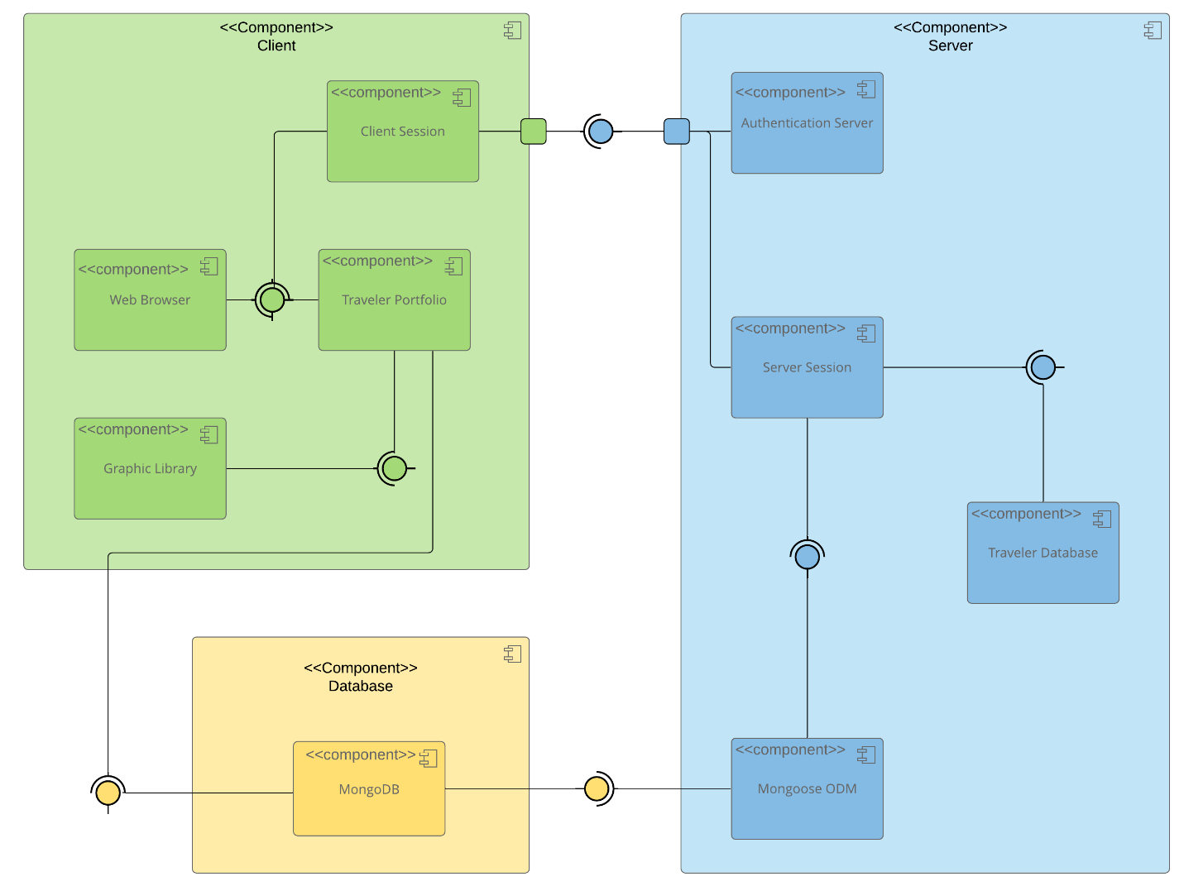

The diagram above illustrates the MEAN component-based development approach, where a software system is divided into components and interfaces that are reusable and replaceable.
From the diagram, we can see that our system has three main high-level components (model elements): The client-side model (front-end), the server-side model (communication layer), and the database model (back-end). From the connection relationship between the high-level components, we can see that the database has an Indirect connection to the client component, indicating that the client must communicate with the database only through the server, which acts as a middleware between MongoDB and the client. The communication between the server and the database, though, is performed via the Mongoose ODM component that maps MongoDB documents into Node.js objects. Similarly, we can identify the need for ports to communicate between the client and the server components through an API interface.
The diagram also presents the existence and the communication of several sub-components within each main component. For example, the server will consist of the authentication and server sub-components that will fetch data from the database. The Client main components will be responsible for managing the client session, establishing the web browser connection, and rendering the received data through the graphic library on the device’s screen. To conclude, the components diagram above ensures a smooth and secure communication channel between all the app’s components, while authenticating users and rendering the desired data according to the defined user role (permissions).

Sequence Diagram

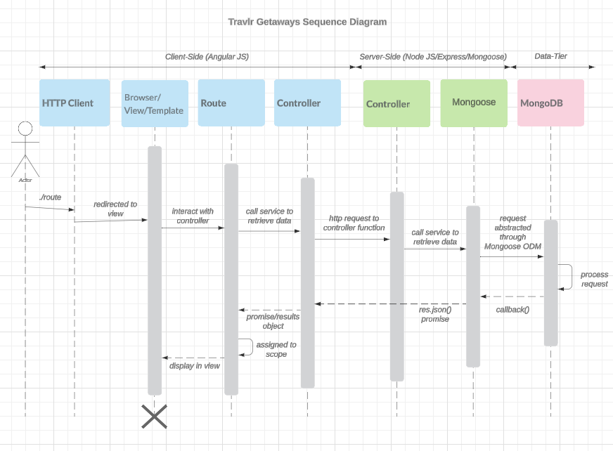

As described in the previous topics above and shown in the sequence diagram, our full-stack application will pass interactions between the front, client-side end, and the server-side end, and back to the client’s display. The flow begins with the actor navigating to a specific web application page route via HTTP request in his browser, such as a GET to retrieve data or a POST request to send data. The browser identifies the user’s request and routes it to the dedicated controller via a service call. From there, the controller, through the Express framework, receives and analyzes the HTTP request, applies logic, and then, through a RESTful API, tries to contact the database. As mentioned, the interaction with the Mongo databases is done via the Mongoose ODM connection library that abstracts the request and performs some CRUD operations in the database. For example, a client enters a web address to access the homepage of our database; the router redirects the request to the API controller, which recognizes that there is no data attached, and the user is only requesting to see the content of the page. Then, our controller asks Mongoose to bring him some information from the database to display the page. After a short run, the database pulls the requested data from the dedicated drawer, AKA a collection, and returns it to Mongoose in a JSON format, a JavaScript Object Notation. After turning around and running back to the controller with the data in his hands, our controller validates the data and seals it with a response that is all . Humor aside, the data, after being checked and validated with a positive response, is now ready to be embedded into the finely prepared template by the browser inside the requested view (webpage) by the user, and Voula, the page is live. The beauty in the process, though, is in the interaction between the various components, layers, and synchronous execution of the request. Similarly, the interaction between the router and the server-side controller can perform multiple operations, such as inserting data into the database, modifying it, or deleting it. Again, such an architecture allows for great modularity, scalability, high performance, security, and ultimately, getting the job done.

Class Diagram

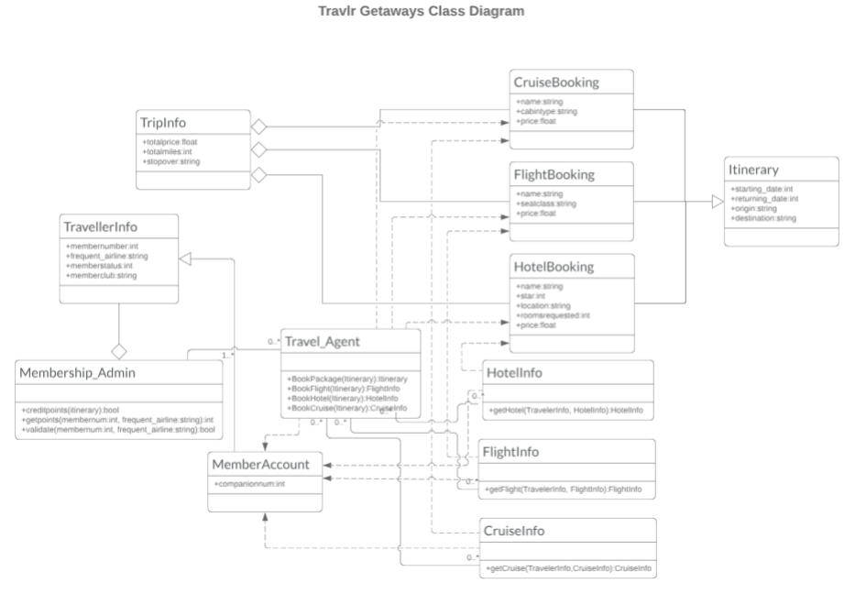

To address the requested functionality for the Travlr Gateways website, based on the provided wireframes and requirements, the necessary functionality will be established as follows, as shown in the class diagram above. As we can see, the platform will feature several high-level master classes, including Travel Agent and Member Account. The Agent class will have access to all the details for each trip package, such as flights, cruises, and hotels, and it will be able to view and reserve any trip for its clients. On top of that, each trip class, such as FlightBooking or HotelBooking, will provide all the information needed to construct the itinerary and provide data to the TripInfo class. Similarly, the MemberAccount class will fetch data from the travel packages and act as an interface to the private user details, such as membership status or member club benefits, via the TravellerInfo class and the Membership_Admin class, which will perform actions on the user account.

API Endpoints
Method | Purpose | URL | Notes
GET | To fill data from the database to fill the Homepage with the main heading article, blog teaser articles, latest Testimonials, and the images for the main view. | http://localhost:3000/api | Retrieve a list of the latest blog articles and testimonials for the homepage view, as well as the addresses for the required graphic media.
GET | Inflate the Travel page with the most attractive travel packages and images. | http://localhost:3000/api/travel | Returns a list of all the travel packages and their associated image to display on the Travel page. Each item contains a unique link to the given article.
GET | Access a single travel package on its own dedicated page. | http://localhost:3000/api/travel/DAWR210315 | Returns single travel package instance, identified by the travel package ID passed on the request URL, for instance: “DAWR210315” is the package name identifier.
GET | Inflate the Rooms page with the most attractive hotel booking packages and their corresponding room images. | http://localhost:3000/api/rooms | Returns a list of all the hotel packages to display on the Rooms page. Each item contains a unique link to the given rook booking page.
GET | Access a single hotel room booking page to see full details about the offer. | http://localhost:3000/api/rooms/First Class Room | Returns a single room booking instance, identified by the room name ID passed in the request URL, for example: “First Class Room” is the room name identifier.
GET | Load the Contact Us page by reading and populating it with the company’s contact information details from the database. | http://localhost:3000/api/contact | Returns a list of all unique company details for customers to contact. For example, the headquarters address, department phone numbers, and so on.
POST | Sends the filled contact us form details in an encoded and secure way inside the request body as api/contact/x-www-form-urlencoded and stores the data in the database. | http://localhost:3000/api/contact | Returns a JSON 201 OK response and a confirmation message if all fields were filled and the data was stored successfully. Otherwise, a 200 OK response is returned, indicating that the request was received and processed, although the data hasn’t been stored, as one or more fields were not filled by the user.
GET Request for /api/contact /api/contact 200 response - POST /api/contact 201 response - POST
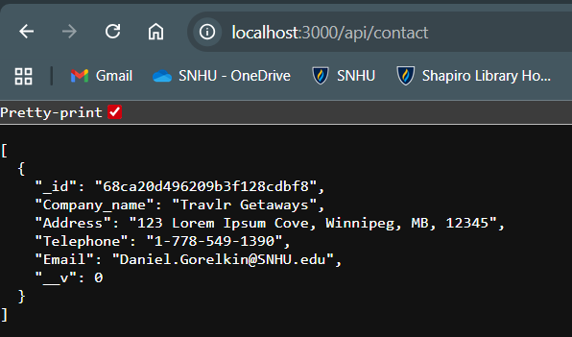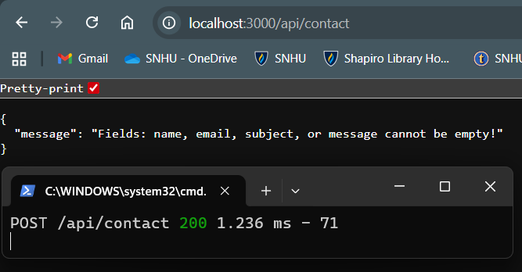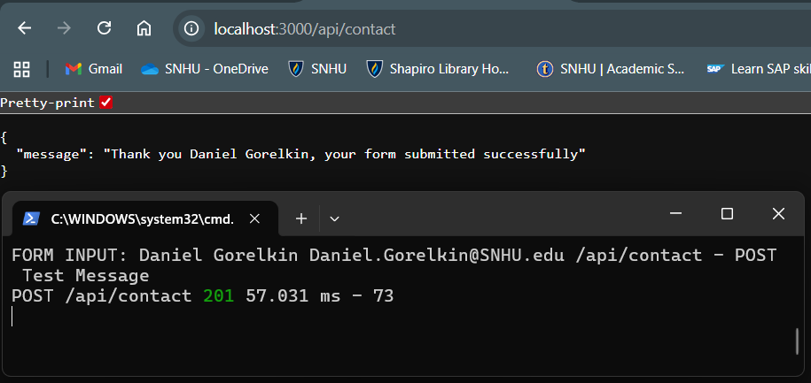

The User Interface

The following screenshots demonstrate the layout and the UI design for the app’s admin management SPA page.
At first, after loading the initial page and accessing the app’s administrator zone, some functionality like adding or updating items, is disabled for security concerns.

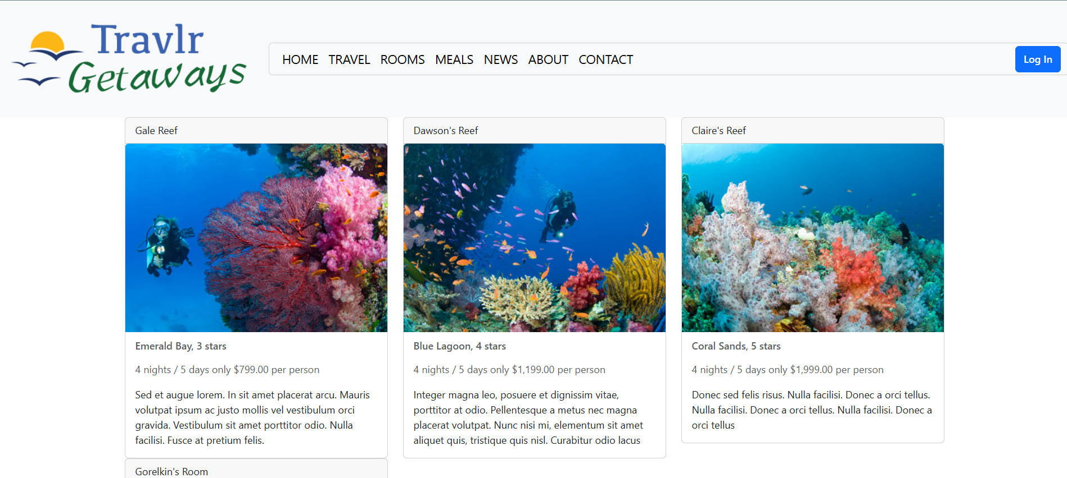
Hence, only an authorized admin user, after successfully logging in, can execute the administrative functionality, such as adding trips or modifying the existing ones.

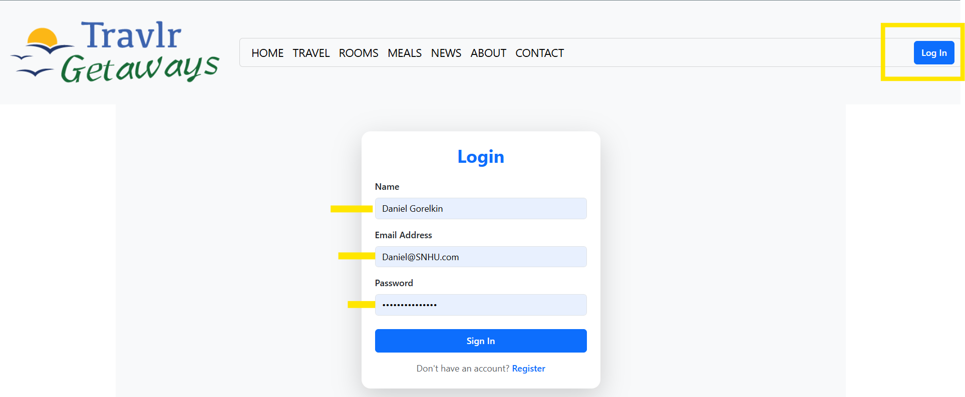
Only after authenticating the user and validating that the API is secure, signed, and the Token is valid, will the admin user gain access to the management system functionality.

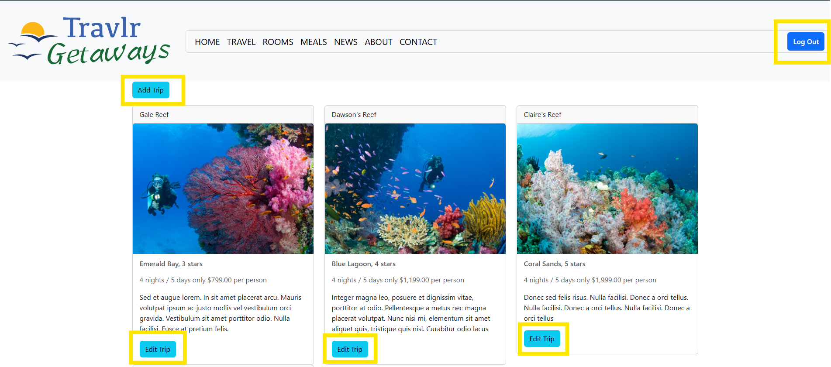

Ultimately, managing the trips will be available through filling out the dedicated form and submitting it to our database through the exposed API endpoints.
- A new trip object added screenshot:
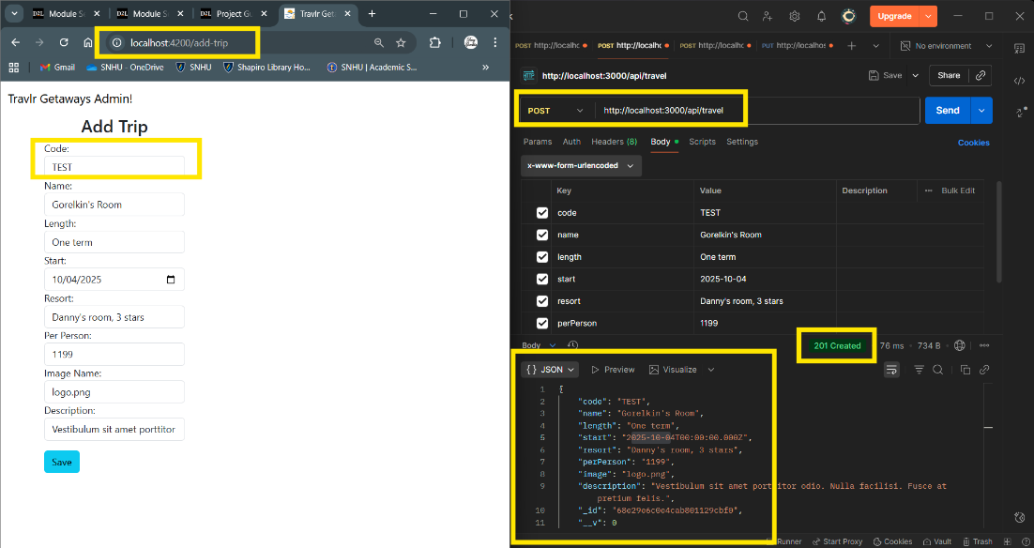

(2) The Edit trip screen layout:
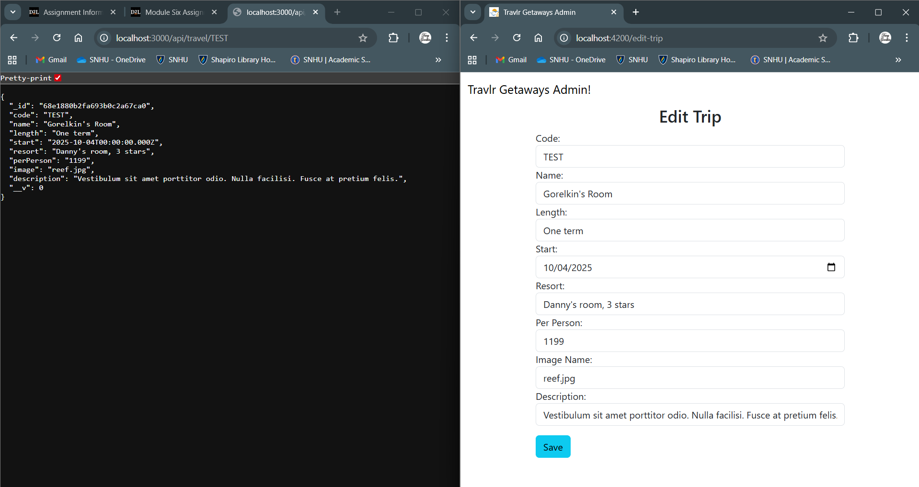

(3) The updated UI screen:
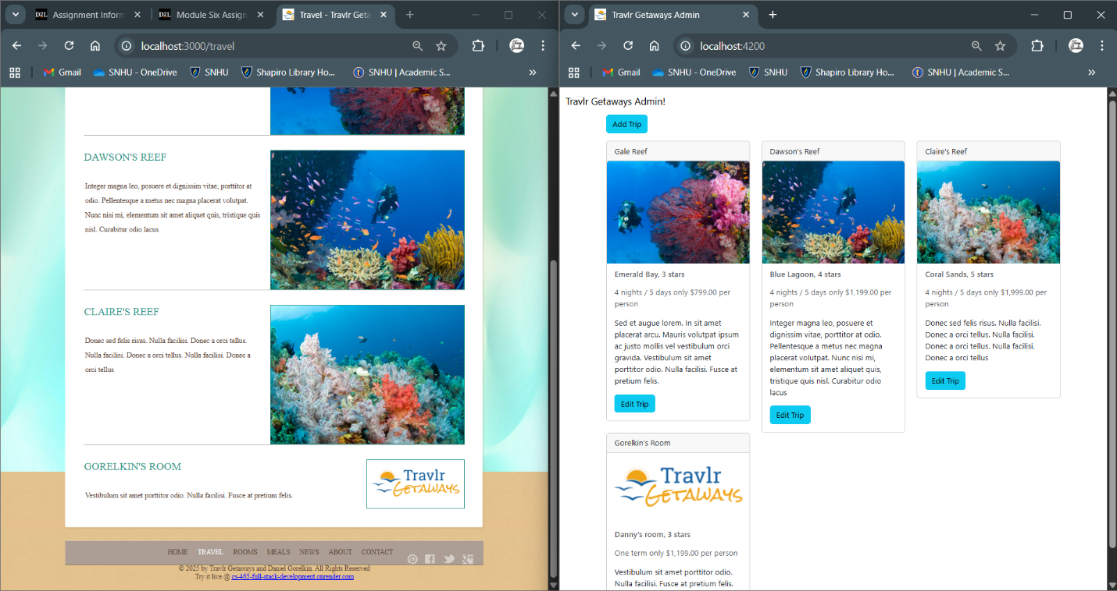

To summarize, we can easily compare the user-end multi-page structure to the admin-side single-page application structure. The Angular project structure used in the admin-facing application is built using a single-page application (SPA) framework, which differs from the Express user-facing application that runs on the server side and executes directly in the user's browser. Unlike the server-side frameworks, Angular serves the page only once, at the time of loading, and constantly updates its content by using API calls to the database through the server. Additionally, it supports the components, services, and modules, unlike the MVC structure in Express, to provide rich and robust functionality.
However, such an architecture suffers from noticeably slower loading of the initial page when the app is accessed, and may introduce additional challenges for SEO with search engines. The build and development process itself is also more complex and time-consuming compared to traditional multi-page applications. However, it provides a beautiful tradeoff, such as a fast, smoother user experience after the initial load, with rich interactive features like live updates and working offline capabilities with smooth transitions and animations.
As mentioned and demonstrated in the screenshots above, Angular communicates with the database using the CRUD commands through API calls. Testing the proper functionality could be done with external tools such as Postman, DBeaver, or even direct access to the database itself. Postman, for example, allows us to send GET, POST, PUT, DELETE, and other commands to the app’s defined endpoints, thereby mimicking its functionality of interacting with the database and sending and retrieving data from it. However, even though such functionality has been tested and is successful, we still need to ensure that the data is rendered adequately on our application page and is up to date with the database records and vice versa.
With that said, each structure has its own pros and cons, but the real power lies in combining the two to achieve great performance and an outstanding UI. Therefore, building an Express application for the customer side with the administration functionality using Angular will provide a fine blend of functionality, stability, speed, and interactive behavior.

